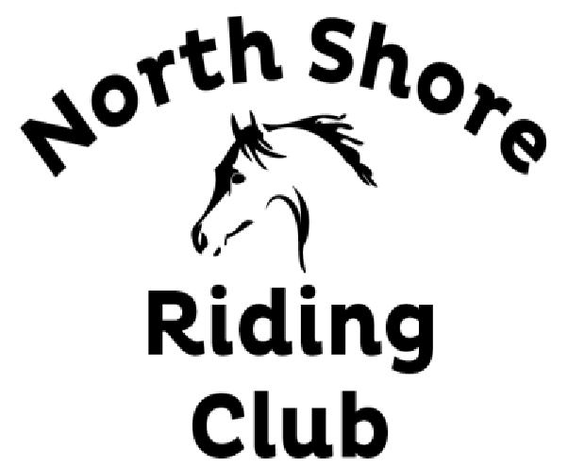

North Shore Riding Club
109 Awanohi Road, RD2, Albany, 0792
www.northshoreridingclub.org.nz

Dear Applicant,
Thank you for your interest in joining the North Shore Riding Club Inc. The club was formed in 1938, is a not for profit Incorporated Society and owns approximately 230 acres of land in Redvale. The land is a combination of grooming/riding facilities, grazing, and native bush.
We have a constitution, which protects the Club and its assets with the emphasis on catering for adult riders.
The committee consists of a President, three Vice Presidents, a Secretary, Treasurer and eight committee members who are all volunteers and are elected annually to manage the Club. We have three Grazing Coordinators who manage the herds, paddock rotation and work alongside our groundsman to ensure the horses and the land are well cared for. We graze up to 50 horses on the front valley and 20 on the back valley. We often have a waiting list as we do not replace horses during the wetter months. Back valley grazing is only available to senior members (over 17 years) due to access and isolation. Your horse needs to be comfortable in a herd of approx 12 horses. Hay is fed out over the winter and there is an annual levy for this.
As a grazing member you would need to be available to move your horse every Saturday before 1pm as the herd goes to a fresh paddock on this day. We also worm the horses 4 times per year on the same day and this is compulsory. Horses must be presented at the appropriate time to the vet on worming day.
During the year “members only” events are organised and when ground conditions are suitable, general riding is available over the land. All non grazed paddocks can be ridden in and there are cross country jumps and bush tracks for use by members. During the winter when these facilities are closed the three sand arenas and the internal road can be ridden. We have an online booking system for the arenas and we have regular clinics which can be attended by club members and non-members if there are spaces. You may also bring your instructor to the club but the arena must be booked and a small fee paid.
Livery or agistment is not provided by the Club. All care for your horse is to be provided by you and the expectation is that you attend to your horses needs regularly. Horse welfare is top priority at the Club. We have a very caring horse community and help will always be available in an emergency.
The gates of the club are always kept locked and your key may not be loaned to anyone. To do so may jeopardise your membership.
Please complete the attached application form and send it to the above address. Do not include any payment as your membership has to be approved at the monthly committee meeting. Once accepted you will be contacted and advised of the date of the compulsory introductory talk. At this meeting, the Bylaws and rules will be explained and you will have a chance to ask questions. This is where payment will be made and you will get your key.
If you have any questions please don’t hesitate to contact bronwyn@firstequine.co.nz.

Full Name:
Occupation:
Postal Address:
Post Code:
Email:
Phone:
Age: D.O.B. if under 17:

Have you belonged to NSRC in the past? If so approximate years?
Do you know any current NSRC members? If so who?

Have you been a member of any other horse or pony clubs? If so, where and approximately how long?

Why would you like to join the NSRC?

What kind of riding do you do?
Referee 1: Phone:
Referee 2: Phone:
Emergency Contact: Phone:
Please complete ONLY if you require grazing
Where is your horse currently grazing?
Current grazing contact number:
I want grazing on Front Valley: Back Valley: I don’t mind:
Name of horse: Gender:
Age of horse: Breed:
Has your horse grazed in a group grazing environment in the past?
How often do you visit your horse?
Will you require a float park? Will you require a locker?

DECLARATION
The committee reserves the right to remove any member from our membership list (and therefore access to our facilities) or not renew said membership should they not comply with our Bylaws, Rules and requirements of our constitution. Therefore, please complete the following declaration.
I (print full name) declare that to the best of my knowledge, the answers to the questions on this application are correct, and I understand if any false information is given, or material facts suppressed, I may not be accepted or if I am granted membership this may be revoked.
I authorise you to contact my referees for verbal references. Information so gained is supplied in confidence as evaluative material and will not be disclosed to me.
I have read and fully understand this declaration:

Signature: Date:

FEES PAYABLE ON CONFIRMATION OF MEMBERSHIP
(all include GST of 15%)
NOTE: FOR FAMILY GROUPS there is a 10% reduction for three members in one family and a 20% reduction for four or more members in one family (this applies to riding members only)
ENTRANCE FEE per rider (new or rejoin) | 60.00
ACTIVITIES LEVY (one off payment per family) | 150.00
SENIOR RIDING ANNUAL SUBSCRIPTION | 330.00
COMBINATION JUNIOR RIDING (under 17 years at 1st July) with compulsory active SENIOR RIDING parent as member | 620.00 plus entrance and activities fee.

FOR ADMINISTRATION ONLY | Date application received: | Induction talk date:
Fees received: | Grazing placement advised: | Database updated:

